Essential |  | FORM 1  Deadline : October 05, 2026

Space Only Installation(Modification) Application

Please Submit the application to :
WSC 2026, Contractor : Rabbit Co., Ltd. / Contact. DongHyun Yoon
T. +82-70-4172-7775, F. +82-31-5175-0714, M. +82-10-3398-4285, E-mail : hidedaka@rabbitspace.co.kr

1. Applicant Information
Company Name |  | Booth No.
Address |  | E-mail
Telephone |  | Fax
Contact Person |  | Mobile

※ Together with Space Only Installation (Modification) Application, two copies each of the ground plan and elevation plan must be submitted to receive pre-approval for booth construction.
※ Upon submitting booth design plans, positions of event stage must be accurately shown. Booth construction may not be approved if event stages are positioned too close to neighboring booths and determined to cause interference with operations of other booths.
2. Space Only Construction Company
Company Name |  | Booth No.
Address
Manager |  | Team/ Position | /
Tel. |  | FAX
Mobile |  | Email | @
Cause of Design Modification | (Only upon design modification)
We submit the Space Only Installation (Modification) application along with the required appendix.
※ Appendix : Space Only ground plan and elevation plan, additional facility position indication
Company name
Booth No. | Authorized Person
Date | Signature

Optional |  | FORM 2  Deadline : October 05, 2026

Application for Subsidiary Facilities
Please Submit the application to :
WSC 2026, Contractor : Rabbit Co., Ltd. / Contact. DongHyun Yoon
T. +82-70-4172-7775, F. +82-31-5175-0714, M. +82-10-3398-4285, E-mail : hidedaka@rabbitspace.co.kr

1. Applicant Information
Company Name |  | Booth No.
Address |  | E-mail
Telephone |  | Fax
Contact Person |  | Mobile

2. Application and Cost
Category |  | Unit Cost× Units(A) | VAT 10% | TOTAL
Electricity | 220V (single-phase) | 70USD/Kw× ( ) Kw = ( USD) | USD | USD
Electricity | 380V (three-phase) | 70USD /Kw× ( ) Kw = (USD) | USD | USD
Electricity | 220V (single-phase) 24 hours | 100USD /Kw× ( ) Kw = (USD) | USD | USD
Plumbing |  | 200USD /unit× ( ) units= (USD) | USD | USD
Compressed Air |  | 200USD /unit× ( ) units= (USD) | USD | USD
Wired Internet Lines (Speed up to 500MB)  Splitters and routers are not allowed |  | 200USD /port× ( ) ports= (USD) | USD | USD
Total |  |  | USD

※ The payment should be completed by no later than, September 30, 2026. If the payment is not confirmed, it will be considered as cancellation.
 | Company name
 | Booth No. |  | Authorized Person
 | Date |  | Signature
Optional |  |  |  | FORM 3  Deadline : October 05, 2026

Booth Cleaning
Please Submit the application to :
WSC 2026, Contractor : Rabbit Co., Ltd. / Contact. DongHyun Yoon
T. +82-70-4172-7775, F. +82-31-5175-0714, M. +82-10-3398-4285, E-mail : hidedaka@rabbitspace.co.kr

1. Applicant Information
Company Name |  | Booth No.
Address |  | E-mail
Telephone |  | Fax
Contact Person |  | Mobile

2. TYPE OF CLEANING
No. | ITEM | UNIT VALUE | QUANTITY(Day) | Quote | TOTAL(USD)
1 | Daily cleaning  service | Stand up to 50 m²  200 USD / Per day |  | 200 USD
2 | Daily cleaning  service | Stands of 50 to 100 m²  300 USD / Per day |  | 300 USD
3 | Daily cleaning  service | Stands up to 150 m²  400 USD / Per day |  | 400 USD

※ The payment should be completed by no later than September 30, 2026. If the payment is not confirmed, it will be considered as cancellation.

 | Company name
 | Booth No. |  | Authorized Person
 | Date |  | Signature
Optional |  |  |  | FORM 4  Deadline : October 05, 2026

Audio/Visual forms
Please Submit the application to :
WSC 2026, Contractor : Rabbit Co., Ltd. / Contact. DongHyun Yoon
T. +82-70-4172-7775, F. +82-31-5175-0714, M. +82-10-3398-4285, E-mail : hidedaka@rabbitspace.co.kr

1. Renting Item
Product | Description | Qty | Unit Cost | Amount
Projector | 10,000ansi |  | 800 USD
Projector | 5,000ansi |  | 500 USD
Projector | 4,000ansi |  | 300 USD
LED TV  (Full HD) | 65” |  | 1500 USD
LED TV  (Full HD) | 60” |  | 1300 USD
LED TV  (Full HD) | 55” |  | 1200 USD
LED TV  (Full HD) | 50” |  | 1000 USD
LED TV  (Full HD) | 46” |  | 800 USD
LED TV  (Full HD) | 40” |  | 600 USD
LED TV  (Full HD) | 32” |  | 500 USD
LED TV Stand | Floor stand |  | 150 USD
Speaker/Amp set | Amp, Speaker, mic. |  | 700 USD
Lap top computer | Core i7 |  | 250 USD
Desk top PC | 19” Monitor |  | 200 USD
Monitor | 19” |  | 80 USD
Monitor | 21” |  | 150 USD
Monitor | 24” |  | 200 USD
Grand Total |  |  |  | USD
Rates for use of Subsidiary facilities may change depending on circumstances.
For information about part name and Unit Cost, please refer to the guide page of application forms on web site. Above rental price is inclusive not 10% VAT.

※ The payment should be completed by no later than, September 30, 2026. If the payment is not confirmed, it will be considered as cancellation.
 | Company name
 | Booth No. |  | Authorized Person
 | Date |  | Signature
Optional |  |  |  | FORM 5  Deadline : October 05, 2026

Booth carpets
Please Submit the application to :
WSC 2026, Contractor : Rabbit Co., Ltd. / Contact. DongHyun Yoon
T. +82-70-4172-7775, F. +82-31-5175-0714, M. +82-10-3398-4285, E-mail : hidedaka@rabbitspace.co.kr

1. Applicant Information
Company Name |  | Booth No.
Address |  | E-mail
Telephone |  | Fax
Contact Person |  | Mobile

ITEM | Carpet type | Carpet number | Booth dimension | UNIT PRICE  (sqm) | TOTAL
Flooring carpet | Standard carpet |  |  | 15 USD
Flooring carpet | Upgraded carpet |  |  | 50 USD

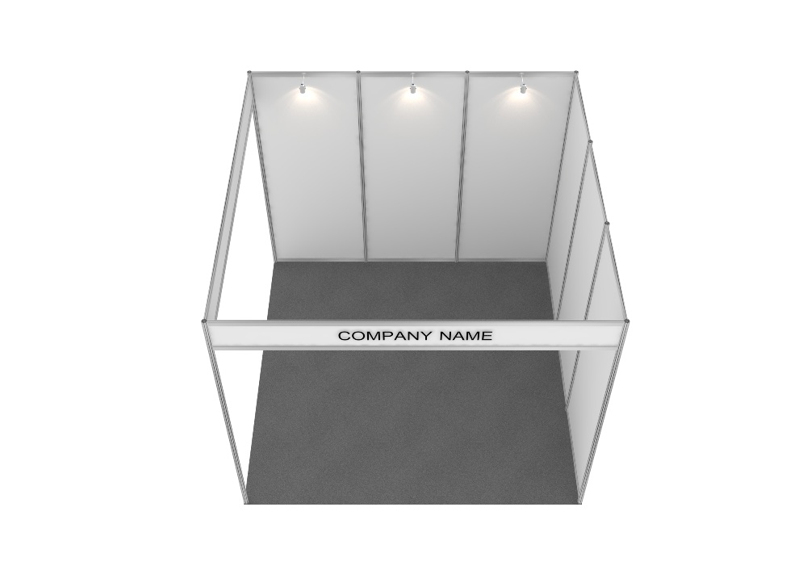
￭ Please look at the carpet samples on the next page and choose it. There are two options for carpets.

Company name
Booth No. | Authorized Person
Date | Signature
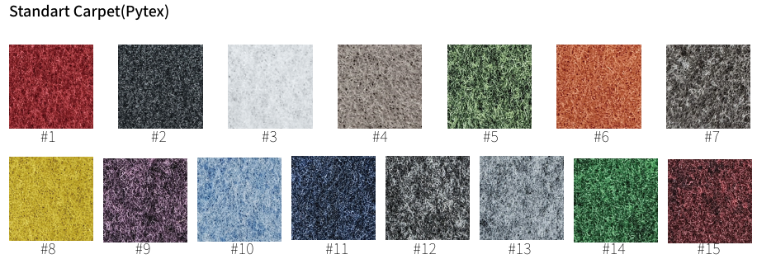

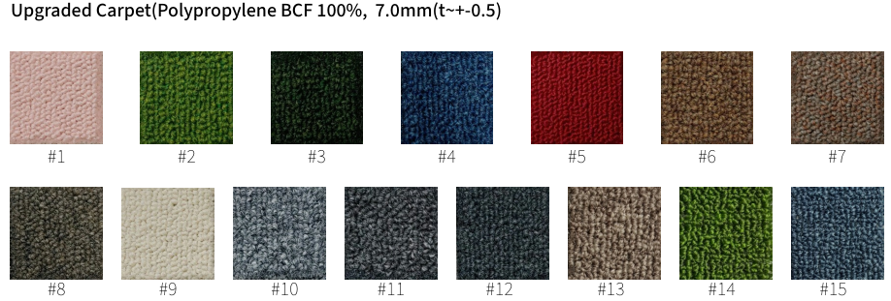
￭ Side of carpet will be finished by edge frame.(Upgrade carpet only)

Optional |  | FORM 6  Deadline : October 05, 2026

Printing service

Please Submit the application to :
WSC 2026, Contractor : Rabbit Co., Ltd. / Contact. DongHyun Yoon
T. +82-70-4172-7775, F. +82-31-5175-0714, M. +82-10-3398-4285, E-mail : hidedaka@rabbitspace.co.kr

1. Printing item
Product | Description | Dimension | Unit Cost | Remarks
Inkjet printing | Color printed/Sticker | 1sqm  (1m x 1m) | 50 USD | Need to check files
Cutting letter | Inkjet printed |  | Need to check files | Need to check files

Grand Total

Please send printing files to us. Contractor will be checked working files. And then exhibitor will get quotation from supplier.
Email : hidedaka@rabbitspace.co.kr
Printing files format: AI file(Adobe illustrator), EPS, JPEG(High resolution) only
Above printing & production prices are not inclusive 10% VAT.

※ The payment should be completed by no later than, September 30, 2026. If the payment is not confirmed, it will be considered as cancellation.

 | Company name
 | Booth No. |  | Authorized Person
 | Date |  | Signature
Optional |  |  |  | FORM 7  Deadline : October 05, 2026

Application for Furniture & OA Rental

Please Submit the application to :
WSC 2026, Contractor : Rabbit Co., Ltd. / Contact. DongHyun Yoon
T. +82-70-4172-7775, F. +82-31-5175-0714, M. +82-10-3398-4285, E-mail : hidedaka@rabbitspace.co.kr

1. Rental Item (Refer to the attached item list)
Product | Description | Qty | Unit Cost | Amount

Grand Total
Rates for use of Subsidiary facilities may change depending on circumstances.
For information about part name and Unit Cost, please refer to the guide page of application forms on web site. Above rental price is not inclusive 10% VAT.

※ The payment should be completed by no later than, September 30, 2026. If the payment is not confirmed, it will be considered as cancellation.

Company name
Booth No. | Authorized Person
Date | Signature

Furniture List
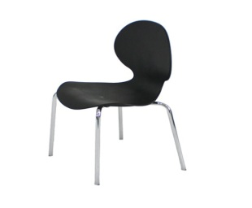 |  | 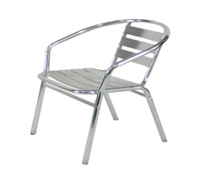 |  | 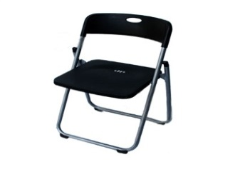
* FC-001(Black/White) |  | * FC-002 |  | * FC-003
* Design Chair |  | * Cyber Chair |  | * Folding Chair
* 440x430x440mmH |  | * 500x400x415mmH |  | * 460x420x430mmH
* $35 |  | * $20 |  | * $12
 |  | 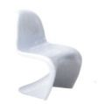 |  | 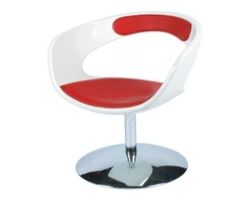
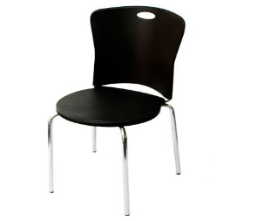

* FC-005 |  | * FC-006 |  | * FC-007 (Red/Black)
* Pinocchio Chair |  | * F.R.P Chair |  | * Easy Chair
* 580x510x760mmH |  | * 480x450x450mmH |  | * 620x470x420mmH
*$25 |  | * $45 |  | * $50
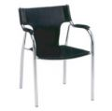 |  | 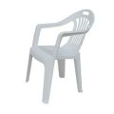 |  | 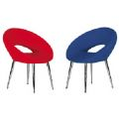
* FC-009 (Black/White) |  | * FC-010 |  | * FC-011(Red/Blue)
* Arm Office Chair |  | * Parasol Chair |  | * Meeting Chair
* 460*550*450mmH |  | * 550x450x450mmH |  | * 585x620x450mmH
* $25 |  | * $10 |  | *$50

All item is not included VAT 10%
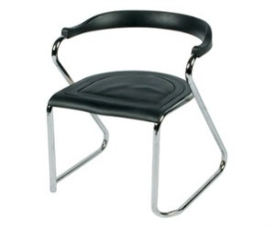 |  |  | 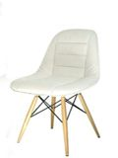 |  |  | 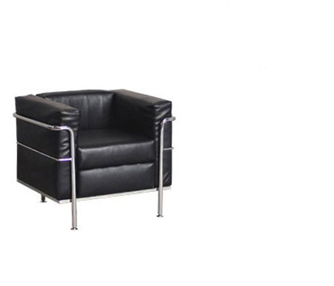
* FC-004 |  |  | * FC-013 |  |  | * FC-016(Black/White)
* Round Chair |  |  | * Eiffel Chair |  |  | * Sofa
* 420x420x420mmH |  |  | * 470x400x430mmH |  |  | * 800x700x430mmH
* $20 |  |  | * $35 |  |  | * $70
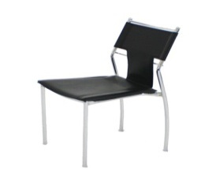 |  |  | 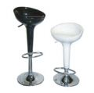 |  |  | 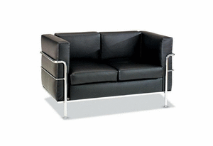
* FC-008 (Black/White) |  |  | * FC-014(White/Black) |  |  | * FC-017(Black/White)
* Arm Office Chair |  |  | * High Stool |  |  | * Sofa
* 440x550x450mmH |  |  | * 500x500x720mmH |  |  | * 1350x700x430mmH
* $30 |  |  | * $45 |  |  | * $130
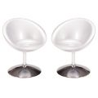 |  |  | 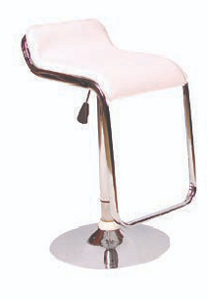 |  |  | 
* FC-012 |  |  | * FC-015 |  |  | * FC-018
* Round F.R.P Chair |  |  | * High stool |  |  | * Apple Chair
* Φ640x450mmH |  |  | * 500x500x720mmH |  |  | * 600x600x400mmH
* $55 |  |  | * $45 |  |  | * $45
All item is not included VAT 10%
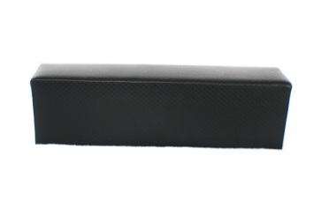 |  |  | 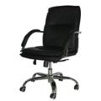 |  |  | 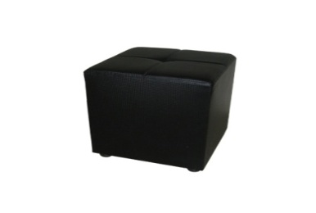
* FC-019 |  |  | * FC-022 |  |  | * FC-025 (White/Black)
* Bench Chair |  |  | * VIP Chair |  |  | * Cube Chair
* 1450x400X400mmH |  |  | * 620x550x450mmH |  |  | * 380x380x400mmH
* $60 |  |  | * $60 |  |  | * $25
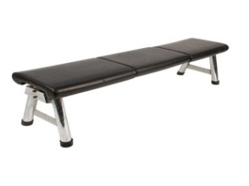 |  |  | 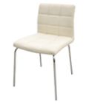 |  |  | 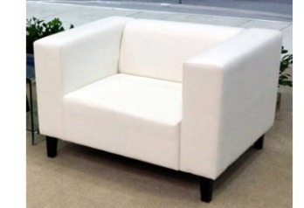
* FC-020 |  |  | * FC-023 |  |  | * FC-026
* Steel Bench |  |  | * Ivory Chair |  |  | * VIP Sofa (1Person)
* 1500x470x400mmH |  |  | * 400x470x760mmH |  |  | * 870x740x735mmH
* $60 |  |  | * $45 |  |  | * $100
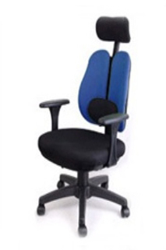 |  |  | 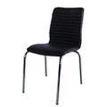 |  |  | 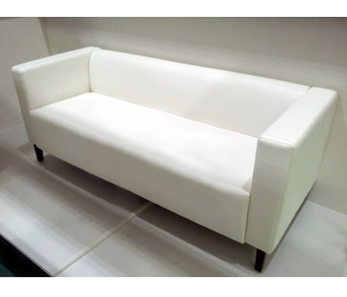
* FC-021 |  |  | * FC-024 |  |  | * FC-027
* Office Chair |  |  | * Square Chair |  |  | * VIP Sofa (2Person)
* 580X470X450mmH |  |  | * 425x410x455mmH |  |  | * 1380x740x735mmH
* $45 |  |  | * $25 |  |  | * $180

All item is not included VAT 10%

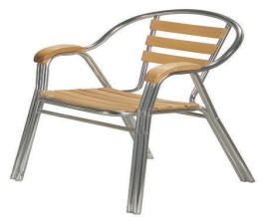 |  |  | 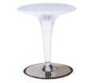 |  |  | 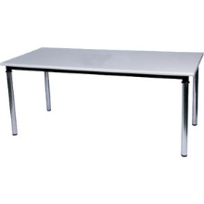
* FC-028 |  |  | * FT-006 |  |  | * FT-004
* Wood Cyber Chair |  |  | * F.R.P Table |  |  | * Rectangular Table
* 585x560x430 |  |  | * Φ600x670~870mmH |  |  | *1800x700x730/1500x700x730/
* $24 |  |  | * $50 |  |  | 1200x700x730mmH
 |  |  |  |  |  | * $48/$42/$36
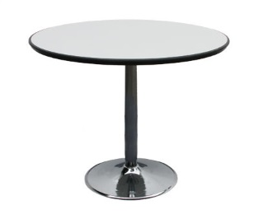

 |  |  | 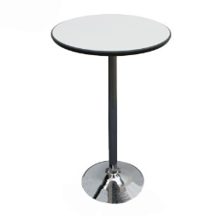 |  |  |  | 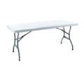
* FT-001 (White/Wood) |  |  | * FT-007 |  |  | * FT-005
* Round Table |  |  | * Bar Table |  |  | * Dura Table
* Φ900x730/Φ750x730mmH |  |  | * Φ600x1100mmH |  |  | * 1800x750mm
Φ600x730mmH |  |  | * $50 |  |  | * $42
* $45/$36/$32
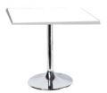 |  |  | 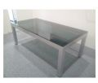 |  |  | 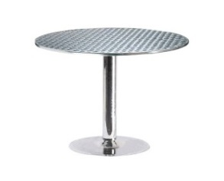
* FT-002 |  |  | * FT-008 |  |  | * FT-003
* Square Table |  |  | * Sofa Table |  |  | * Cyber Table
* 600x600x750mmH |  |  | * 1200x600x460mmH |  |  | * Φ800x730mmH
* $40 |  |  | * $72 |  |  | * $55

All item is not included VAT 10%
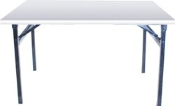 |  |  | 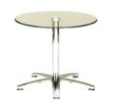 |  |  | 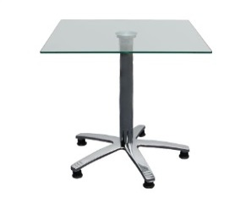
* FT-009 |  |  | * FT-010 |  |  | * FT-011
* Event Table |  |  | * Glass Coffee Table |  |  | * Square Table Glass
* 1200x600x720mmH |  |  | * 700x750mmH |  |  | * 600x600x750mmH
* $40 |  |  | * $50 |  |  | * $48
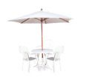 |  |  | 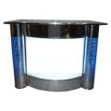 |  |  | 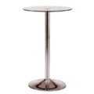
* FT-012 |  |  | * FT-013 |  |  | * FT-014
* Parasol & Table |  |  | * Steel Information |  |  | * Glass Bar Table
* Parasol:Φ1800x2200mmh |  |  | * 1500x1000mmH |  |  | * Φ600x1000mmH
Table:Φ800x760mmh |  |  | * $180 |  |  | * $54
* $48
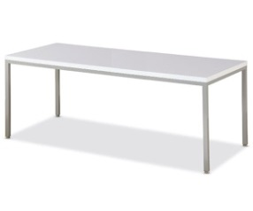 |  |  | 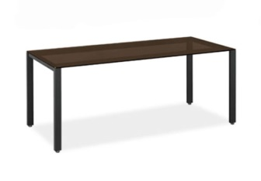
 |  |  | * FT-016
* FT-015 |  |  | * Glass Table
* High Glossy Table |  |  | * 1800*750*740mmh
* 1800*750*740mmh |  |  | * $135
1200*750*740mmh
* $150/$100

All item is not included VAT 10%
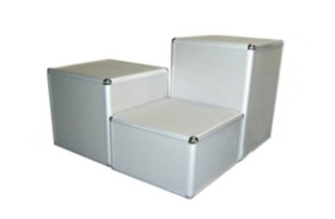 |  | 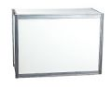 |  | 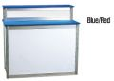
* FS-001 |  | * FS-002 |  | * FS-003 (Blue/Red)
* Display Cube |  | * Reception counter |  | * Display Base
* 500x500x750//500... |  | * 1000x500x1000mmH |  | * 1900x600x974mmH
500x500x250...mmH |  | * $50 |  | 1050x600x974mmH
* $30/$28/$24 |  |  |  | * $96/$72
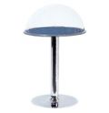 |  | 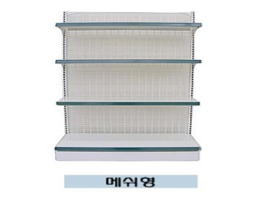 |  | 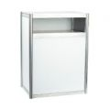
* FS-005 |  | * FS-006 |  | * FS-007
* Display Acryl Table |  | * Store Stand |  | * TV/VCR Stand
* Φ500x750mmH |  | * 900*중단(350) |  | * 700x500x1000mmH
* $38 |  | 하단(450)*1570mmh |  | * $48
 |  | * $120
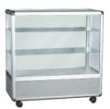 |  | 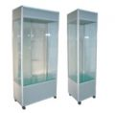 |  | 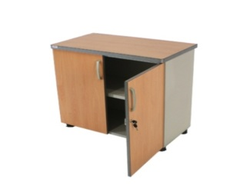
* FS-009 |  | * FS-010 |  | * FS-011
* Display Showcase |  | * Display Showcase |  | * Storage Unit
* 900x450x900mmH |  | * 900x450x2000mmH |  | * 750x350x750mmH
* $80 |  | 500x500x2000mmH |  | * $50
 |  | * $200/$150

All item is not included VAT 10%
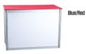 |  |  | 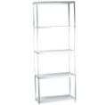 |  |  | 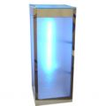
* FS-004 (Blue) |  |  | * FS-013 |  |  | * FS-016
* Display Base |  |  | * Shelf Unit |  |  | * Poly display
* 1900x600x762mmH |  |  | * 700x350x1850mmH |  |  | * 400X400X1000mmH
1050x600x762mmH |  |  | * $48 |  |  | * $84
* $75/$50
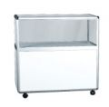 |  |  | 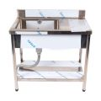 |  |  | 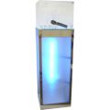
* FS-008 |  |  | * FS-014 |  |  | * FS-017
* Display Showcase |  |  | * Kitchen Unit |  |  | * Acrylic poly display
* 900x450x900mmH |  |  | * 900x600x900mmh |  |  | * 400x400x1000mmH
* $80 |  |  | * $72 |  |  | * $96
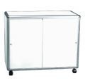 |  |  | 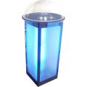 |  |  | 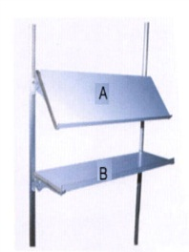
* FS-012 |  |  | * FS-015 |  |  | * FS-018
* Cupboard |  |  | * Round poly display |  |  | * Shelf Unit
* 900x450x750mmH |  |  | * 400X400X1000mmH |  |  | * 1000x300mm
* $60 |  |  | * $96 |  |  | * A-$24/B-$18

All item is not included VAT 10%

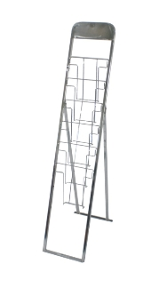 |  |  | 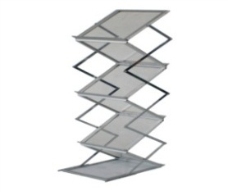 |  |  | 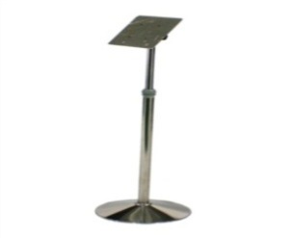
* FD-001 (Silver) |  |  | * FD-002 |  |  | * FD-003
* Catalogue Holder |  |  | * Catalogue Holder |  |  | * Spec Stand
* 260x1560mmH |  |  | * 255x310x1470mmH |  |  | * 300x300x1000mmH
* $20 |  |  | * $45 |  |  | * $36
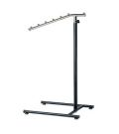 |  |  | 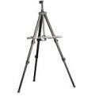 |  |  | 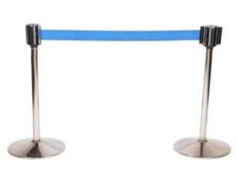
* FD-005 |  |  | * FD-006 |  |  | * FD-007
* Cloth Hanger |  |  | * Spec Stand |  |  | * Guard-Rail
* 450*940~1620mmH |  |  | * 500x400~700mmH |  |  | *Φ300x500~2000x900mmH
* $18 |  |  | * $18 |  |  | * $48
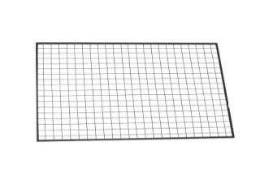 |  |  | 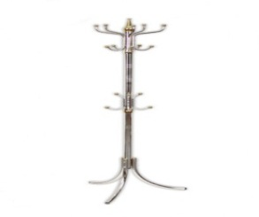 |  |  | 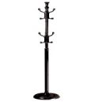
* FD-009 |  |  | * FD-010 |  |  | * FD-011
* Steel Mesh |  |  | * Stand Hanger |  |  | * Stand Hanger
* 900x1200mmH |  |  | * 520X1800mmH |  |  | *350x1600mmH
* $18 |  |  | * $24 |  |  | * $18

All item is not included VAT 10%

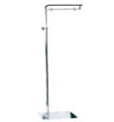 |  |  | 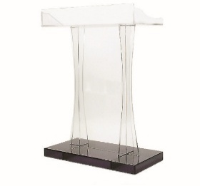 |  |  | 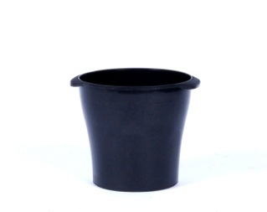
* FD-004 |  |  | * FD-013 |  |  | * FD-016
* Spec Stand |  |  | * Acrylic Platform |  |  | * Wastebasket
* 350x1300~1800mmH |  |  | * 600x400(mm) H:1200(mm) |  |  | * 10ℓ
* $24 |  |  | * $180 |  |  | * $4
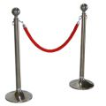 |  |  | 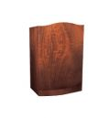 |  |  | 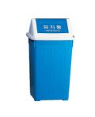
* FD-008 |  |  | * FD-014 |  |  | * FD-017
* Guard-rail |  |  | * Platform Wood |  |  | * Wastebasket
* Φ300x500~1000x950mmH |  |  | * 740x500x1200mmH |  |  | * 45ℓ
* $18 |  |  | * $60 |  |  | * $6
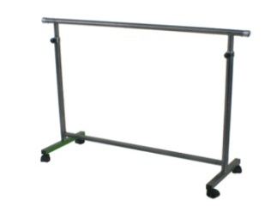 |  |  | 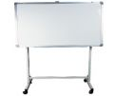 |  |  | 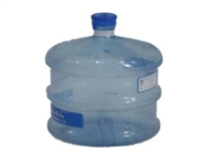
* FD-012 |  |  | * FD-015 |  |  | * FW-001
* Cloth Hanger |  |  | * White Board |  |  | * water
* 900x1000~1500mmH |  |  | * 470x500x460mmH |  |  | * 18.9ℓ
* $18 |  |  | * $60 |  |  | * $12

All item is not included VAT 10%

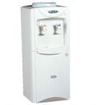

* FE-011
* Water Dispenser
* 350x350x980mmH
* $45

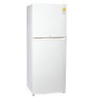

* FE-012
* Refrigerator
* 145ℓ-530x530x1300
230ℓ-580x600x1580
* $100/$150

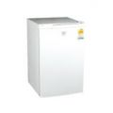

* FE-013
* Refrigerator
* 120ℓ-500*500*820
80ℓ-450*450*730
* $75/$60

All item is not included VAT 10%

